DNA Notes for Forensics:
Central Dogma of Molecular Biology, which states that:
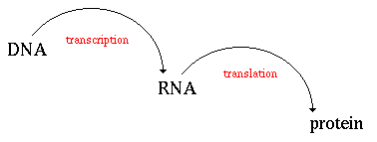
________________________________________________________
DNA Polymerase:
DNA
DNA
RNA Polymerase: uses only the one coding DNA strand
Transcription into mRNA
RNA
tRNA
mRNA
(ribosome translation)
rRNA (L&S)

Ribosomes
Translation at the ribosome into protein

24 AA

Protein
ez
Functional (e.g. muscles)
Structural (e.g. cell wall)

DNA Theory
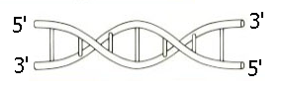
Double Stranded DNA
anti-parallel strands

5’ and 3’ are ends of the sugars connected by phosphates

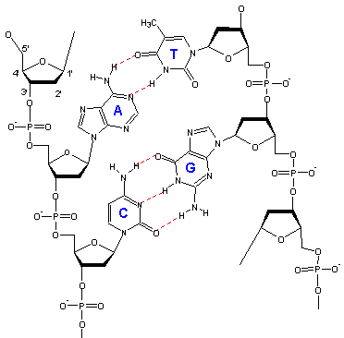
Nitrogenous Bases: N is in the ring
Purine Bases: Pyrimidine Bases:
guanine & adenine cytosine & thymine

No sugar and no phosphate (PO₄⁻³)

Now add sugar = NUCLEOSIDE

Now add phosphate = NUCLEOTIDE

Now you can make Nucleic Acid, DNA or RNA
Make Large DNA molecule for whole class
40 copies of A,T,C,G needs 120 white sugar and phosphate
Scissors, and tape
Assemble and attach to walls
This took a good 30-40 min with everyone on task
Restriction Enzymes cut as molecular scissors at restriction sites which are palindromes
This is a useful tool for molecular biologists that enable them to insert pieces of DNA into plasmids and replicate the DNA many times by growing bacteria that contain these DNA inserted plasmids.
These palindromes are the same Forward and Backward

BOB
MADAM
RACECAR
Nucleotide Palindrome example: TAAT
If the restriction ez makes a Blunt cut in the following: GGC CGG
CCG GCC
Resulting in DNA with blunt ends _____GGC CGG _____
_____CCG GCC_____

or a Staggered Cut that LEAVES STICKY ENDS after cutting the double stranded DNA
CCCAATTCGA
GGGTTAAGCT

RESULTing in 2 sticky ends

CCCAATT AND CGA
GGG TTAAGCT
Blunt Cut Example: EZ # 1 HindIII
A G C C T T A G C C T T A G C C T T
T C G G A A T C G G A A T C G G A A

Sticky Ends
______________ A G C
T C G _____________
Overhang, Restriction Enzymes, Molecular Scissors

Examples of Restriction Enzymes: Hind III
EcoRI
BamHI

Plasmid DNA is circular.
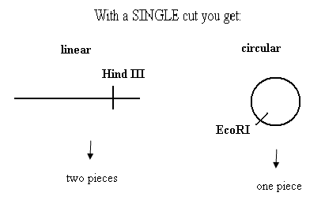

More Examples:
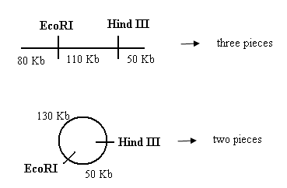

Gel
Lane 1: linear cut DNA Lane 2: circular cut DNA
Three pieces: Two Pieces:
50 Kb 130 Kb
110 Kb 50 Kb
80 Kb
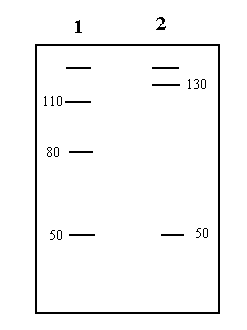

Pipette Challenges
1st do the P200 Micropipette challenge
Use a 1.5 ml microcentrifuge tube to add the following:
- 25 ul green
- 50.0 ul blue
- 35 ul yellow
- 45 ul red
- Total volume ______________
- Now set pipette to total volume and see how close you get, repeat 2X

2nd do the P20 Micropipette challenge
Practice Try 2x Add the following to waxed paper
3 uL red
4 uL blue
2 uL green
1 uL yellow

_____ total volume

Grey pipetteman DO NOT use 2-20
0.5 uL – 10 uL
1) Gilson Blue Pipet 20-200 ul use Yellow tip’s
2) Grey Eppendorf 20-200 uL use Yellow tip’s
3) Gilson Blue Pipet 2-20 ul use small white tip

. . Gel Electrophoresis of DYES, discover the unknown contents
- Do not plug anything into an electrical outlet until your teacher tells you too.
- When pouring 1X TBE over solidified gel, pour into the gel box not on top of the gel itself.
- Do not pour solutions back into the original stock bottle. Pour excess into a labeled beaker (1X TBE)
- Tape trays with masking tape. Set comb into middle row.
- Make 0.8 % agarose in 1 X TBE buffer
~ 0.40g agarose in 50.0mL 1 X TBE buffer
- Microwave 1 min swirl; repeat for 30 s, make sure all is dissolved until uniform throughout
~ wait 10-15min until cool to touch (like a baby’s bottle)
- Pour it into taped Gel tray- be sure comb is set at end of tray
- After gel is set, add ~500.0 ml of 1x TBE to the gel box pouring into the box not on top of the gel
- Do not touch the Pt wires ( I cannot fix if they are disconnected) i.e. do not dry the inside of the gel boxes ever!
(10)You will load gels with dyes next class.

TBE stands for Tris Borate EDTA.
People also use TAE (Tris Acetate EDTA). Make up a 10x stock using cheap reagents. Do not use expensive 'analytical grade' reageants. Cheap Tris base and boric acid can be bought in bulk.
Recipe for 2L of 10xTBE
- 218g Tris base
- 110g Boric acid
- 9.3g EDTA
Dissolve the ingredients in 1.9L of distilled water. pH to about 8.3 using NaOH and make up to 2L.

PCR with Polly Dornette from DESTINY
DNA
RFLP restriction fragment Length Polymorphism
STR SBI Short tandem repeats
VNTR: variable number tandem repeats, current analysis
Use introns (Old Junk DNA) in last 4-5 years recognize some of the DNA not junk can be: promoter regions etc, there are more
Exons are the genes
PCR Mix: DNA of interest + Master Mix
Containing:
- DNA polymerase i.e. TAQ Polymerase
- dNTP’s
- Mg+2 acts as coenzyme
- Buffer
- 2 primers forward and reverse
PCR simulation: new tube for each, change tips each all tubes are different colors
- Step 1 yellow put 20 ul Master Mix + primers into PCR tubes put into all 6 PCR tubes
- Step 2 is add Template to each tube
- Tube 1 DNA template labeled is the DNA from crime scene
- Tube 2 suspect 1
- Tube 3 suspect 2
- Tube 4 suspect 3
- Tube 5 suspect 4
- Tube 6 clear negative no DNA
Run to Red (Red is +)
20 uL dye

Dye Name
Explorer II
Explorer I
Green
Orange
Blue
Yellow

1st space well, skip the first well, if possible place 20 ul of
dyes with spaces apart from each other.
REPEAT for DNA gels except
- Put combs at the black end of the gel not the middle
- Add Carolina Blue stain – 2 drops per 50.0 ml gel after cooling before pouring the gel into the taped gel tray.
- Add 16 drops or 640 ul of Carolina Blue stain (C30528) to 400 ml running buffer. Or 960 ul (24 drops) per 500 ml TBE buffer.
- Run gels at 100 volts for ~ 60 min. Turn off power and remove gel to gel staining tray.
- Stain gels by covering with Carolina Blue Final DNA Stain for 15- 20 min. rinse with distilled water (chlorinated water bleaches the gels).

DNA Sequencing
A T G C
SEQUENCING
GEL

Radioactive Nucleotides dTTP, dGTP, dCTP, dATP:
Coding Strand: A-T G-C
T-G-T-C-A-T-G-G-C-C-T-T-A-T-C
A C A G T

Protein Synthesis

rRNA is ribosomal RNA, large and small subunits make up one ribosome where the protein is elongated (synthesized)
mRNA is messenger RNA which carries the message for proteins
tRNA’s have CODONS: 3 N.T. BASES CODE FOR AN AMINO ACID
All types of RNA use ribose and uracil instead of deoxyribose and thymine

DNA START CODON: STOP CODONS can be
AUG ----------------------------- ---------------------- UGA
UAG
UAA

AUG codes for Methionine which will be the first AA for any protein
20 AMINO Acids

Protein Synthesis

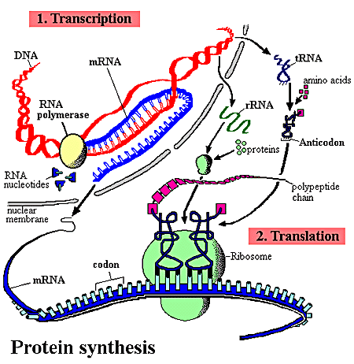

Legend: Process whereby DNA encodes for the production of amino acids and proteins.
This process can be divided into two parts: 1. Transcription Before the synthesis of a protein begins, the corresponding RNA molecule is produced by RNA transcription. One strand of the DNA double helix is used as a template by the RNA polymerase to synthesize a messenger RNA (mRNA). This mRNA migrates from the nucleus to the cytoplasm. During this step, mRNA goes through different types of maturation including one called splicing when the non-coding sequences are eliminated. The coding mRNA sequence can be described as a unit of three nucleotides called a codon.
2. Translation The ribosome binds to the mRNA at the start codon (AUG) that is recognized only by the initiator tRNA. The ribosome proceeds to the elongation phase of protein synthesis. During this stage, complexes, composed of an amino acid linked to tRNA, sequentially bind to the appropriate codon in mRNA by forming complementary base pairs with the tRNA anticodon. The ribosome moves from codon to codon along the mRNA. Amino acids are added one by one, translated into polypeptidic sequences dictated by DNA and represented by mRNA. At the end, a release factor binds to the stop codon, terminating translation and releasing the complete polypeptide from the ribosome.
One specific amino acid can correspond to more than one codon. The genetic code is said to be degenerate.

