Acids and Bases Notes:
General Properties of Acids
- Sour Taste
- Acids at H react with metal H₂ gas + salt
- color change in acid base indicator
- Turn blue litmus red
- Acid + base H₂O + salt
- Acids are electrolytes
- Strong acid 100% ionized v.s. weak (not 100 % ionized)
- Naming of Acids for Binary and Ternary (Oxyacids)
- Strong Acids Binary EX. __________________________
or Oxyacids have 2 or more Oxygens than Hydrogens in the formula Examples: _______________________________________________________________________________________________________________________________
- Weak acids are: HF and Organic Acids Ex. _____________________________________
- Mineral acids contain no carbon e.g. N, P, S, F
- Types of Acids,
  - Arrhenius, _________________
  - Bronsted Lowry, _______donor__________
  - Lewis ______________
- Types of Acids, give examples
  - Polyprotic ___________
  - Monoprotic __________
  - Diprotic __________
  - Triprotic __________

- Acids in water

- Hydrochloric acid + water _____________

- Acetic acid in water ______________

General Properties of Bases
- Bitter Taste
- Slippery
- Change color of an acid base indicator
- Turn red litmus blue
- Bases are electrolytes
- Bases react with Acids H₂O + salt
- Ammonia, Potassium Hydroxide and amines (CH₃NH₂) are examples
- Types of Bases, Arrhenius, Bronsted-Lowry, Lewis
  - Arrhenius, _________________
  - Bronsted Lowry, ______________
  - Lewis ______________

- Strong Bases are from Group IA Ex. _______________
- Weak bases all others
  - Metal hydroxides, Ex. ____________
  - Amines, Ex. ________________
- Bases in water
- Ex.
- Sodium hydroxide + water _______________ _______________________________________________________

- Ammonia + water _______________ _______________________________________________________

- Methylamine + water _______________ _______________________________________________________

Bronsted-Lowry Acids and Bases
Ex.
- Hydrochloric acid + water _____________
- Ammonia + water ________________________
- Sulfurous Acid + water _________________________
- Phosphoric Acid + water _________________________________
- Phosphorous Acid + water _______________________
- Sulfurous Acid + water _______________________
- Aluminum hydroxide + water ______________________
- Neutralization Reactions:
- Process in which an acid and a base cancel or neutralize each other's properties

- Example: HCl + NaOH NaCl + H₂O

- Written in ionic form:

H⁺ (aq) + Cl⁻ (aq) + Na⁺ (aq) + OH⁻ (aq)
Na⁺ (aq) + Cl⁻ (aq) + H₂O (l)

- In neutralization, the H⁺¹ from the acid and the OH⁻¹ from the base combine to produce water. The positive ion from the base and the negative ion from the acid remain spectator ions in solution. Evaporating the water would produce the crystallized salt.
H⁺ (aq) + OH⁻ (aq) H₂O (l)
(acid) (base) (water)
Ex.
Sodium Hydroxide + Hydrobromic Acid __________________________
Net Ionic
_______________________________________________________
Lithium Hydroxide + Hydroiodic Acid ______________________________
Net Ionic
_______________________________________________________
Ammonia + Hydrobromic Acid __________________________________
Net Ionic
_______________________________________________________
SALTS
PROPERTIES
- Salts consist of any + ion (except H⁺) and any - ion (except OH⁻)
- There are thousands of salts possible
- There are no "general characteristics" of salts; some are very soluble in water, others are very insoluble in water
- Some ions in salts may have a characteristic color:

Cu⁺¹, Cu⁺² blue CrO₄⁻² yellow

Ni⁺² green Cr₂O₇⁻² orange

Fe⁺³ brown I⁻¹ purple/brown

Hg⁺¹ orange

Salts are named by saying the positive ion first (usually a metal) followed by the negative ion(may be a nonmetal or a polyatomic ion
Hydroxides and Oxides (binary compound with oxygen)
I. Basic Anhydride (basic oxide) reacts with water alkaline solution
Ex. Sodium Oxide + water aqueous hydroxide

II. Acid Anhydride: Oxide reacts with water Acid
Ex:
Sulfur Dioxide + water _____________

Sulfur Trioxide + water _____________
______________________________________________________

Vocabulary
Amphoteric ______________________
Acid Anhydride ______________________
Ex. ________________________________
Basic Anhydride _______________________

Chemical Reactions:
- Acids + Metals
  - Zinc + Sulfuric acid_______________ ________________________________________________________
  - Magnesium + Nitric acid _______________ ________________________________________________________
- Acids with Metal Oxides
  - Copper (II) oxide + Sulfuric Acid _______________ ________________________________________________________

- Acids with Carbonates
  - Calcium Carbonate _______________ ________________________________________________________
- Hydroxide with nonmetal oxides
  - Carbon Dioxide + Lithium hydroxide _______________ ________________________________________________________
- Metal Oxide with nonmetal oxides, no water, dry compounds
  - Magnesium Oxide + Carbon Dioxide _______________ ________________________________________________________
Next notes from C. 16

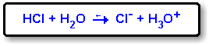

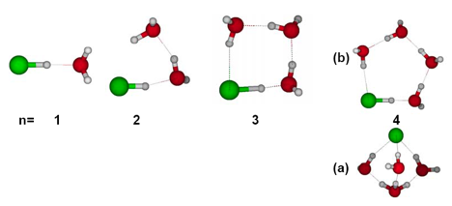

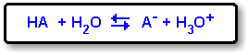

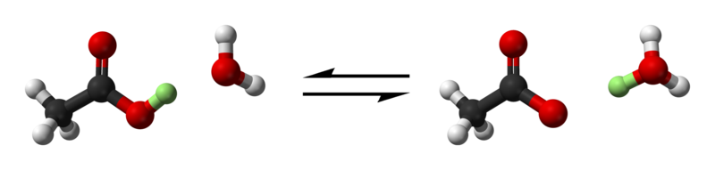

DETERMINING WEAK FROM STRONG BY FORMULA
- Acids:
Binary: HCl, HBr HI strong all others weak
Ternary: the number of Oxygen atoms exceeds number of H atoms by 2 or more, the acid is strong
Polyprotic acids: donate more than one proton – 2nd and 3rd are always weak e.g. H₂SO₄ and H₃PO₄
- Bases: hydroxides of IA and IIA are strong (except Be), all others are weak
pH = -log [H₃O⁺]
pOH = -log [OH⁻]
pKw = pH + pOH

Titration: M_{a}V_{a} = M_{b}V_{b}
Quantity of one reactant is compared to quantity of another
Neutralization reaction: acid + base = water + salt
Equivalence point the quantities of acid and base are exactly equal
Indicators: dyes that indicate when equivalence point is reached (they are a weak acid or a base)
Hydrolysis
The reaction of a salt with water to produce an acidic or basic or neutral solution
- If salt is derived from strong acid and strong base, the solution is neutral pH=7, ex: NaCl
- If salt is derived from weak acid and a strong base, the solution is a base pH > 7, ex: sodium acetate
- If salt is derived from strong acid and weak base, the solution is an acid pH < 7, ex: ammonium bromide
Chapter 16
- Self-Ionization of water Reaction ____________________
- pH of acid solution _____________________
- pH of basic solution ____________________
- pH of neutral solution ___________________
- Define pH scale _________
- Define pH (equation) _________
- Define pOH (equation) ____________________
- Using Table 16-3, list 2 acidic substances ____________________
- Using Table 16-3, list 2 basic substances ____________________
- Calculate pH of a solution of 0.001 M HCl _________________________
- Calculate pOH of a solution of 0.001 M HCl _______________________
- Calculate pH of a solution of 0.001 M KOH ________________________
- Calculate pOH of a solution of 0.001 M KOH _______________________
- Calculate pH of a solution of 0.0025 M HCl ________________________
- Calculate pOH of a solution of 0.0025 M HCl ______________________
- Calculate pH of a solution of 0.0045 M KOH _______________________
- Calculate pOH of a solution of 0.0045 M KOH ______________________
- Define Acid Base Indicator ____________________________
- 2 examples of Define Acid Base Indicators ________________________
- pH meter is ______________________________
- Equivalence point is ____________________________
- End point _______________________________
- Titration is ________________________________
- Determine the Molarity of an unknown acid, if 25.00 ml of it is titrated to its endpoint with 62.5 ml of 0.15 M NaOH. Show calculation. _________________________________________________

- Draw and label titration curve for strong acid/strong base
|
|
|
|
|
|
|
|
|
| __________________________________________________
ml of 0.15 M NaOH
Draw and label titration curve for weak acid/strong base
|
|
|
|
|
|
|
|
|
|
| ____________________________________
ml of 0.15 M NaOH

