Acid, Bases, and Equilibrium TEST REVIEW Name _________________
Acids and Bases
1. All acids are __________________, strong acids are better conductors of electricity.
2. A water solution that conducts electricity is called a(n) _______________________________.
3. Acids taste _________________ while bases taste _______________.
4. Bases feel ______________ and are commonly found in most household __________________.
5. A reaction between an acid and base, called _________________________, forms water and a _______________________.
6. What ion is produced when an acid ionizes in water?

7. What is the difference between a strong acid and a weak acid and the degree of ionization? Give some examples of each.

8. A titration took 60 mL of 0.5 M HCl to neutralize 250 mL of a base with an unknown concentration. Using this information, what was the concentration of the base?

9. During a titration, it takes 55.0 mL of a 0.12 M HCl solution to reach the equivalence point with an unknown concentration of NaOH. What is the molarity of the NaOH solution?

10. 25.2 mL of HCl was titrated with 0.0146 M NaOH. Using the titration curve below, calculate the concentration of HCl.
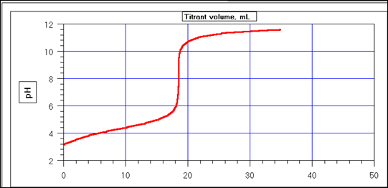

11. Identify the range for an acid and base on the pH scale.
1 2 3 4 5 6 7 8 9 10 11 12 13 14
12. Identify as acid, base, or salt, and then name.
- NaNO₃ _______________________________________________
- H₂SO₄ ________________________________________________
- MgCl₂ _______________________________________________
- NH₃OH _______________________________________________
- HCl ___________________________________________________
- NaOH _________________________________________________
- HC₂H₃O2 ______________________________________________________________________

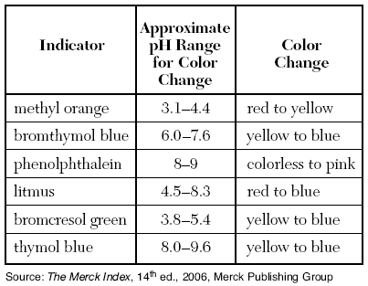
13. A solution of unknown pH was tested with two indicators. Methyl orange turned yellow and bromcresol green turned blue. Which of these could be the pH of the solution?
a. 3.1 b. 5.4 c. 4.0 d. 8.0

14. Calculate the pH of 2.3 x 10-5 M HCl solution.

15. Calculate the hydronium ion concentration of a solution that has a pOH of 12.5.

16. Find the pH and determine whether it is an acidic or a basic solution.
- if the pOH is 4
- if the [H₃O⁺] is 1.0 × 10⁻⁶
- if 0.001 M H₃O⁺
- if the [H₃O⁺] is 3.5 × 10⁻³

17. The diagrams below show a 0.1 M aqueous solution of HCl and a 0.1 M aqueous solution of HF
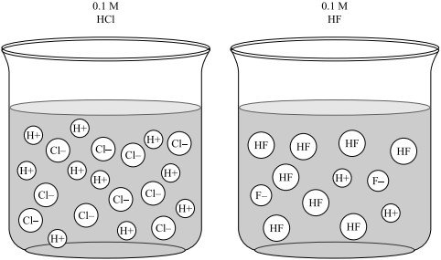
How does the concentration of beaker B compare to beaker A. Explain.

EQUILIBRIUM
1. For any reaction that is at chemical equilibrium, the concentration of the products and reactants _______________ ___________________ and the rate of the forward reaction _________________ the rate of the reverse reaction. When an equilibrium value is very high, such as K=350, it indicates that the ________________ are favored in the reaction.

2. Write the equilibrium expression for the reaction
4 NO (g) + 2 O₂ (g) 2 N₂O₄ (g)

3. Suppose the reaction in #2 above occurs at 1500 K and is determined to consist of 0.15 mol/L NO, 0.43 mol/L O₂, and 0.055 mol/L SO₃. What is the equilibrium constant for the system at this temperature?

4. In the equation in #2 above, what is the effect (shift) on the equilibrium with:
a. increased pressure?
b. decreased oxygen concentration?
5. Write the equilibrium expression for the representation of a reaction:
2A + B 3C + 2D + energy

6. If heat is added to the reaction above, which way will the equilibrium shift?

